**PHASE 5**

**LESSON 5**

**PRACTICE ASSISTED 2**

**INSTALL KUBERNETES ON CLOUD**

**CREATING INSTANCE:**

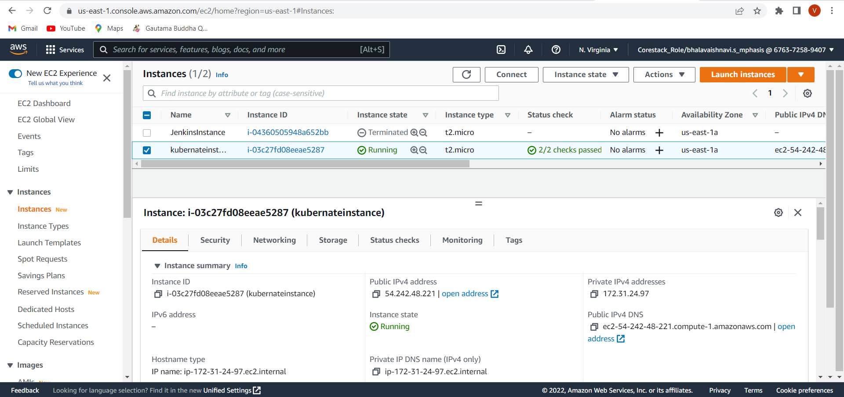

**SETUP ENVIRONMENT:**



